### [HTU | Al Hussein Technical University](https://www.htu.edu.jo/)

**جامعة الحسين التقنية**



**Capstone Project**

**Title:**

**Teeba store(HTU_CAPSTONE_PROJECT)**

Students:

|  |  |
| --- | --- |
| ALA' IBRAHIM ALHAJAR | 9941043609 |

**Abstract**

Since the world is constantly evolving in all directions, we must keep pace with this development, so we decided to develop a modern sales system that helps users in sales and inventory operations instead of the old manual system.

Table of Contents

Chapter 1: Introduction 1

1.1 Overview 1

1.2 Problem Statement 1

1.3 Project objectives 1

Chapter 2: Methodology 8

2.1 Overview 8

2.2 Feasibility Study 8

2.3 Requirements 9

2.3.1 Functional requirements: 9

2.3.2 Non-functional requirements: 10

2.3.3 Tools 10

2.4 Methodology process 11

Chapter 3: Design Models 12

3.1 Overview 12

3.3 Use Case Diagram 13

3.4 Data flow Diagram 14

3.5 ER Diagram 15

Chapter 4: Experiments and results 16

4.1 Overview 16

4.2 Testing methodologies 16

4.2.1 Unit Testing. 16

4.3 Integration testing 23

4.4 System results 23

Chapter 5: Conclusion 24

5.1 Conclusion 24

5.2 Future Work 24

REFERENCES 25

Appendix: 26

Rest of figures: 26

**List of figures**

Figure 1: Context diagram 4

Figure 2: Use Case Diagram 5

Figure 3: ER Diagram 6

Figure 4: Log in page 7

Figure 5: Create item 8

Figure 6: All item 9

Figure 7: Update item 10

Figure 8: Dashbord 11

Figure 9: Create transaction 11

Figure 10: Schema Database 14

# Chapter 1: Introduction

## Overview

This chapter explains the problems with the current system that led us to create a website that addresses these issues, as well as the objectives of the new system and the methodology that will be used.

## Problem Statement

*"Our retail store is currently using a manual cash register system to process transactions, which is causing delays during peak hours and making it difficult to accurately track inventory. We would like to implement a new POS system that integrates with our inventory management software, is able to handle multiple transactions at once, and includes features such as customer loyalty programs and the ability to process returns and exchanges. The system should also be user-friendly for both customers and employees*

## 1.3 Project objectives

This portal will enable us to transfer specialization to achieve several goals, including:

1. Streamline the checkout process: The system should be easy to use, fast, and reliable, so that transactions can be completed quickly and efficiently.
2. Improve inventory management: The system should be able to track inventory levels in real-time, so that businesses can easily reorder items when they run low.
3. Increase accuracy: By automating the sales process, a POS system can help reduce errors and improve the accuracy of sales data.
4. Enhance customer service: By providing detailed sales reports and analytics, a POS system can help businesses understand their customers better and make informed decisions about how to improve the customer experience.

# 

# Chapter 2: Methodology

## 2.1 Overview

This chapter discusses tools used to get the work done, our feasibility study, the requirement (functional and non-functional), and the methodology process of how the project is done.

## 2.2 Requirements

### Functional requirements:

1.2.1.1Admin portal:

* Create items.
* Create transaction.
* Edit profile.
* Create user.
* See all items.
* See all transactions.
* Edit/delete items.
* Edit/delete transactions.
* Edit/delete users.

1.2.1.1Seller portal:

* Create transaction
* Edit/delete transaction

2.3.1.3Accountantportal :

* Edit/delete transaction.
* See all transaction.

2.3.1.4Procurement portal:

* Create items.
* Edit/delete items.
* See all items.

### 2.3.3 Tools

* Visual studio code
* XAMMP
* PHPmy Admin
* Drow.io Diagram
* Google (Meeting, Translate)
* Office 365(Word, PowerPoint)

# Chapter 3: Design Models

## 3.1 Overview

In this chapter, we are talking about how to design and build relationships between system components by using sous diagrams such as the context diagram, the use case diagram, data flow diagram, ER diagram.

3.2 Context diagram

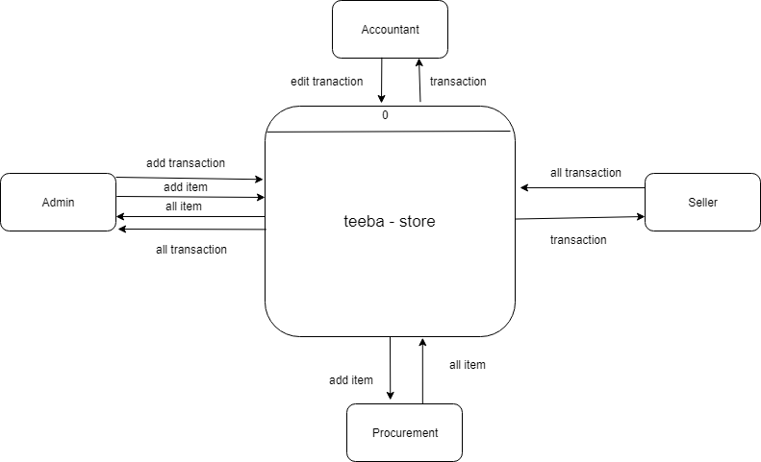

Figure 1: Context diagram

## 3.3 Use Case Diagram

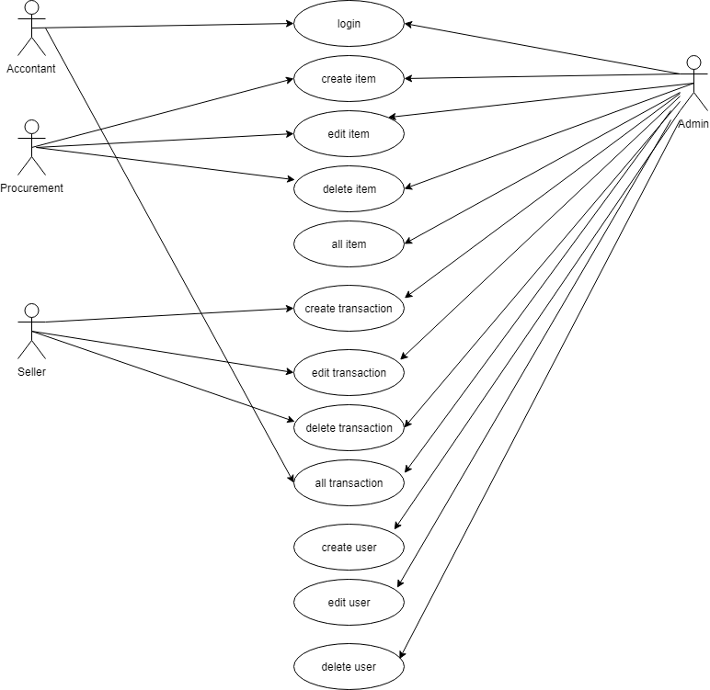

Figure 2: Use Case Diagram

## 3.4 ER Diagram

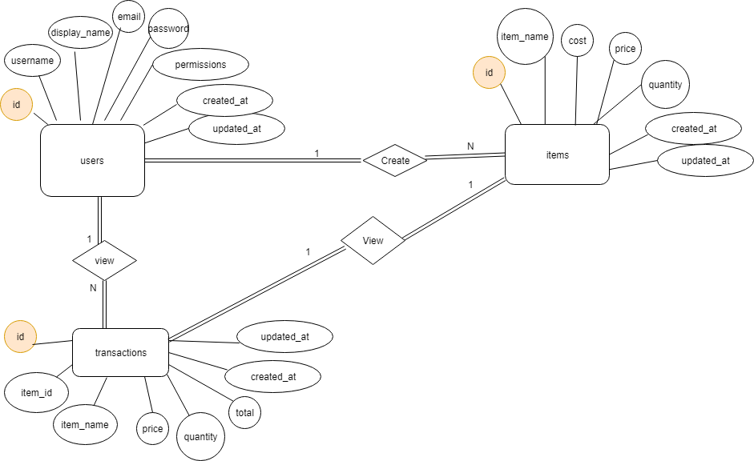

Figure 3: ER Diagram

# Chapter 4: Experiments and results

## 4.1 Overview

In this chapter, we will talk about how we test the system with the intent to find whether it satisfies the specified requirement or not.

### 4.2.1 Unit Testing.

Three types of units are included, the first for the **Login Page**, the second for the **Create items**, and the third for the**Admin portal**.

#### 4.2.1.1 Login Page

It was checked that the data entered in the registration form was saved in Database, and to ensure that the registration and entry laws are applied to the system.

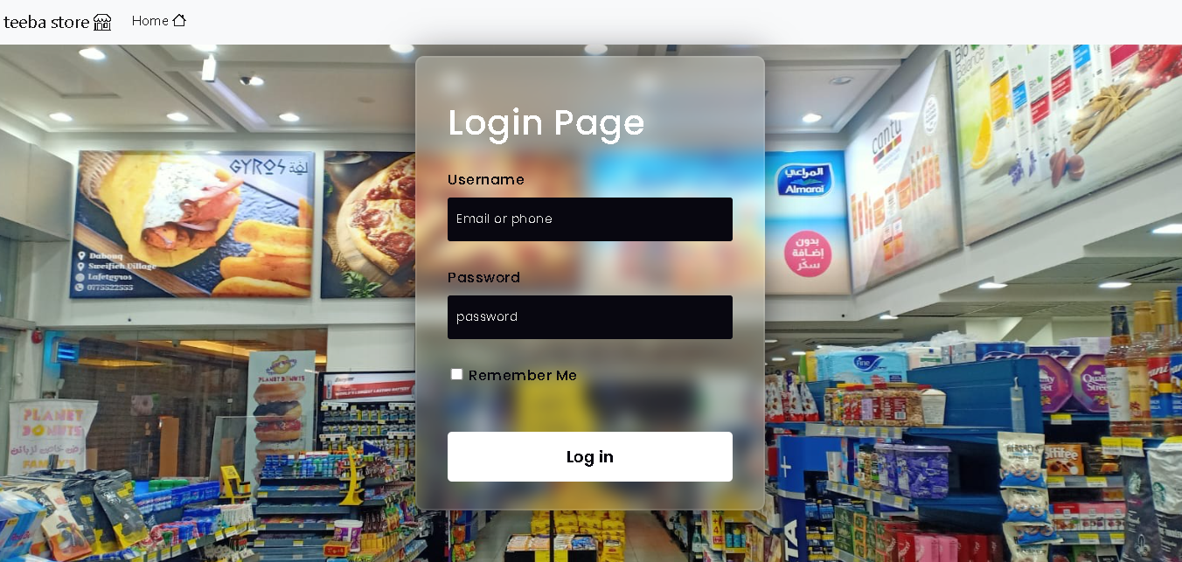

Figure4: Log in page

#### 4.2.1.2 Create items

1. Create item

This page works to create a new item and add it in the data base and display it on the all item page.

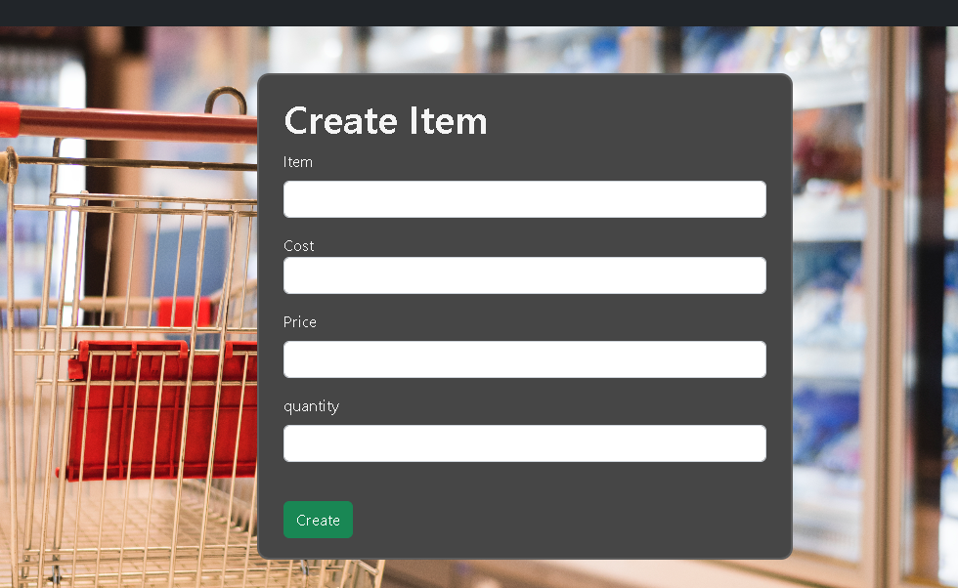

Figure 5: Create item page

1. All Items

This page displays all items that have been created and can be deleted or modified.

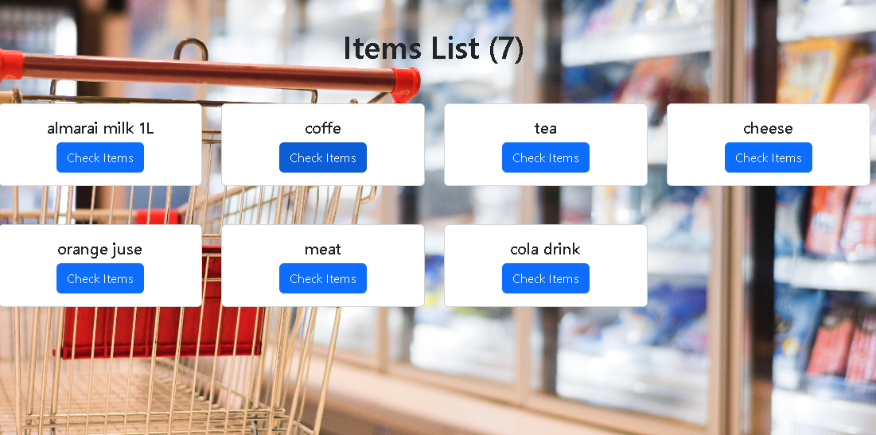

Figure6: All items page

1. Edit Item

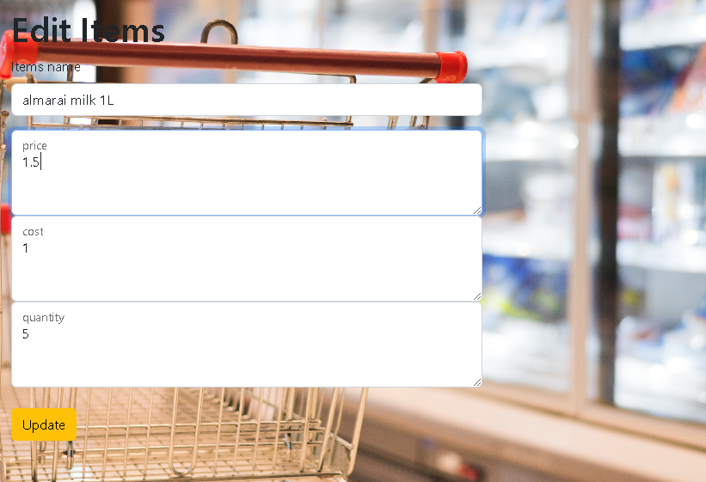

Figure 7: Update Item page

#### 4.2.1.3Admin portal

1. Dashbord

See the admin dashbord page.

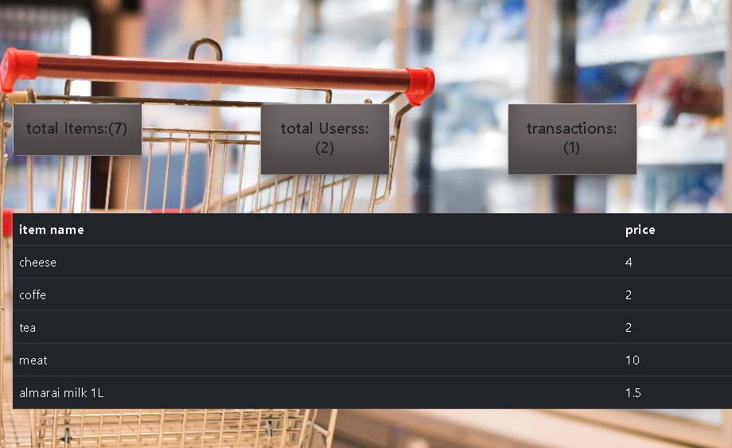

Figure8: Dashbord page

1. Create tranaction

Create any transaction through this page.

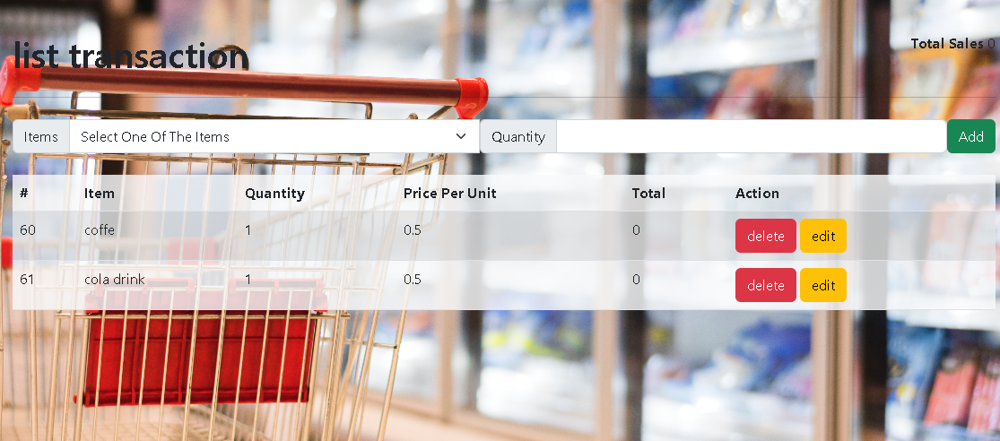

Figure9: Create transaction page

# Chapter 5: Conclusion

## 5.1 Conclusion

## All stages of the system have been reached, their success verified, and the required goalsreached.

## 5.2 Future Work

* Put each item in its own category
* Create a page for users to see the product through which the can purchase.
* Implementation to another language.
* Convert it to an Android and iOS application.
* Implement auto plagiarism check.

# REFERENCES

1. <https://www.w3schools.com/>

To use some code for design and some programming issues

1. <https://stackoverflow.com/>

To come up with some solutions to the problems we were facing

1. https://www.javatpoint.com/software-engineering-incremental-model

The site from which we derived the study strategy

[4] <http://developer.mozilla.org>

Use site to change tag properties in html

[5] <http://githup.com>

This site was used to see some projects and learn from them.

# Appendix:

## Rest of figures: Screenshot data-base.png

Figure 10: Schema Database